***Installation Guide Web Site Prototype***

***Team Project***

***Group C***

# 1 Web Site Prototype

## 1.1 Architecture

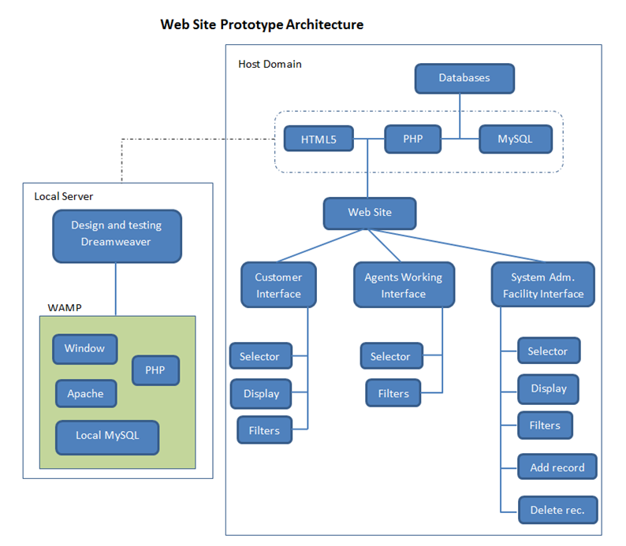

## 1.2 Installation Guide

1. Type the following URL in your browser

<http://www.blesolutions.com/wp-content/themes/bleSite.1.4.2/dbhome.php>

Click enter to access the customers interface

2. At the main menu click “Agents” to access the agents working interface, and click “Managers” to access to the system administration facility interface

3. Enjoy the features designed for this prototype to be very intuitive and friendly

**GUDE TO INSTALL THE PROTOTYPE IN YOUR LOCAL SERVER**

1. Install WAMP in your server, if you do not have it. My recommendation is install “ZEND” server, available for free in its web site. It is the combo of windows, Apache, PHP and MySQL

2. Copy all files that come into the same package on this document named “web_site_prototype_files” and paste them at this location: “C:\Program Files (x86)\Zend\Apache2\htdocs\Barkley_Realtor”. If you change the default location at the time of installing “ZEND” server, then replace for the correct location.

3. Open file “login.php” using your preferred editor and change the database password and database name for the ones in your local server

4. Once all files are correctly located, type in your browser the following path:

“<http://localhost/Barkley_Realtor/webSite_files/dbhome.php>”

Clicks enter and enjoy the web site prototype working locally in your machine. You will be able to enjoy same features and capabilities that when it is uploaded in the internet.